Quiz 1 20/2/2020

In the Hypothetical Machine the contents of memory was as shown. And PC contents is 300. Show the contents of memory and PC , AC , IR after execute three instructions (three fetch cycle and there execute cycle)

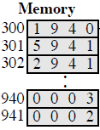

Show the contents of PC , AC and IR and memory after the execution of each instruction of the following program on the Hypothetical Machine:

300 LOAD 550

301 ADD 551

302 STORE 600

Where the contents of memory at 550 is 3 and at 551 is 4.

The following figure provide the main characteristics of Hypothetical Machine.

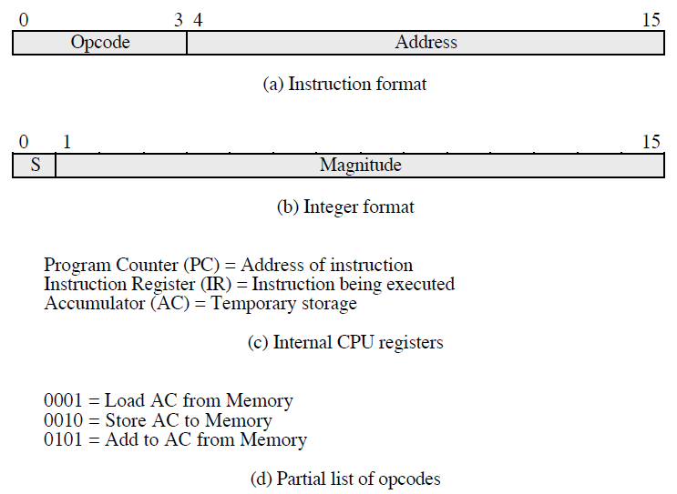

The hypothetical machine also has two I/O instructions:

0011 = load AC from I/O

0111 =store AC to I/O

In these case, the 12-bi address identifies a particular I/O device. Show the program execution for the following program:

1. Load AC from device 5.

2. Add contents of memory location 940.

3. Store AC to device 6.

Assume that the next value retrieved from device 5 is 3 and that location 940 contains a value of 2.

**Answer**

First Instruction:

• Fetching: AC: 0000 IR: 1940 PC: 300

940: 0003 941: 0002

• Execution: AC: 0003 IR: 1940 PC: 300

940: 0003 941: 0002

Second Instruction:

• Fetching: AC: 0003 IR: 5941 PC: 301

940: 0003 941: 0002

• Execution: AC: 0005 IR: 5941 PC: 301

940: 0003 941: 0002

Third Instruction:

• Fetching: AC: 0005 IR: 2941 PC: 302

940: 0003 941: 0002

• Execution: Ac: 0000 IR: 2941 PC: 302

940: 0003 941: 0005

First Instruction:

• Fetching: AC: 0000 IR: 1550 PC: 300

550: 0003 551: 0004 600: 0000

• Execution: AC: 0003 IR: 1550 PC: 300

550: 0003 551: 0004 600: 0000

Second Instruction: • Fetching: AC: 0003 IR: 5551 PC: 301 550: 0003 551: 0004 600: 0000

• Execution: AC: 0007 IR: 5551 PC: 301 550: 0003 551: 0004 600: 0000

Third Instruction: • Fetching: AC: 0007 IR: 2600 PC: 302 550: 0003 551: 0004 600: 0000

• Execution: AC: 0000 IR: 2600 PC: 302

550: 0003 551: 0004 600: 0007

**Memory**

|  |  |
| --- | --- |
| 3005 | 300 |
| 5940 | 301 |
| 7006 | 302 |

After executing the three instructions:

device 5: 0003

940: 2

device 6: 0005